### **SEARCH CONDITIONS**

### Where Clause:

1) The **Where** clause allows you to specify a search condition for the rows returned by a query.

2) Where Clause is use for to filter the record.

3)The WHERE clause is used to extract only those records that fulfill a specified condition.

Syntax:

select column_list from tableName where serach_condition;

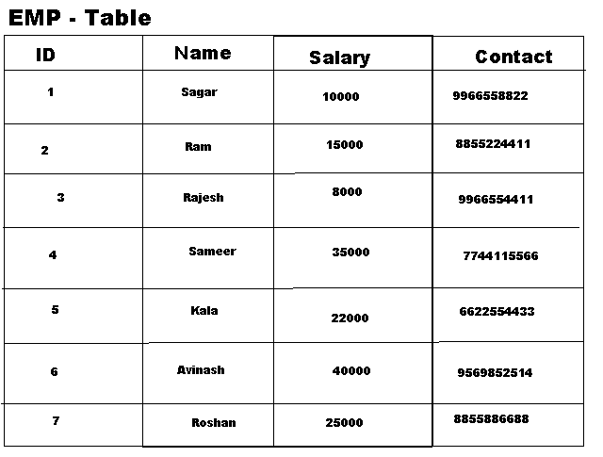

**Filter Example:**

**1) Select * from emp where id=3;**

**2) Select id,name,salary from emp where id=5 and name='Kala';**

**3)select * from emp where id=5 or id=6 or id=4;**

**4) Select id,name,contact,salary from emp where id between 1 and 5**

**5) select * from emp where salary >20000;**

**6) select * from emp where salary >20000 and salary <40000**

**COMPRASIONS operators**

## **Comparison operators :**

**are used in the WHERE clause to determine which records to select. Here is a list of the comparison operators that you can use in MySQL.**

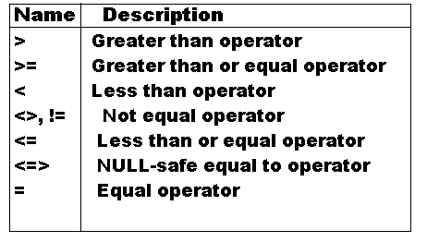

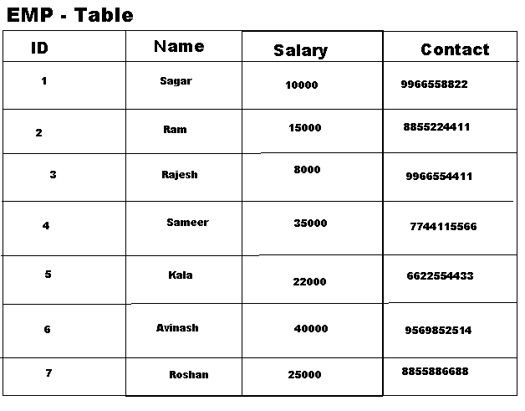

**1) select * from emp where id=1 or id=2**

**2) select * from emp where id>1 and id<5**

**3)select * from emp where salary>=1000 and salary<=40000;**

**IN operation**

# In Clause:

**1) The function returns 1 if expr is equal to any of the values in the IN list, otherwise, returns 0.**

**2) It is used to help reduce the need for multiple Or condition in a SELECT, INSERT, UPDATE, or DELETE statement.**

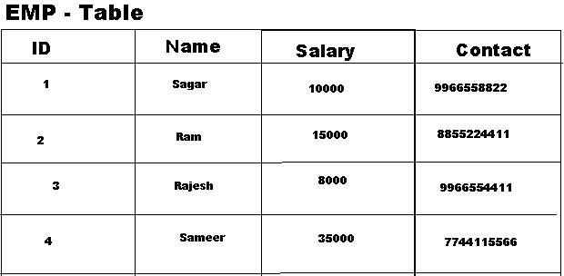

**1) Select 10 in (12,10,45);**

**2)select * from emp where id in (1,2,3,6);**

**3)select * from emp where name in("Sameer",'Raj','Rajesh','Kala');**

**4)select * from emp where name not in("Sameer",'Raj','Rajesh','Kala');**

**5)select * from emp where salary in(10000,8000,40000,22000,35000);**